**Exercise 1: Control Structures**

**Scenario 1:**

**Code:**

DECLARE

    CURSOR customer_cursor IS

        SELECT c.customerid, c.dob

        FROM customers c;

    v_customer_id   customers.customerid%TYPE;

    v_dob           customers.dob%TYPE;

    v_age           NUMBER;

BEGIN

    FOR customer_rec IN customer_cursor LOOP

        v_customer_id := customer_rec.customerid;

        v_dob := customer_rec.dob;

        v_age := FLOOR(MONTHS_BETWEEN(SYSDATE, v_dob) / 12);

        IF v_age > 60 THEN

            UPDATE loans

            SET interestrate = interestrate - 1

            WHERE customerid = v_customer_id;

            DBMS_OUTPUT.PUT_LINE('1% interest applied to Customer ID ' || v_customer_id);

        END IF;

    END LOOP;

    COMMIT;

END;

/

SELECT l.loanid, l.customerid, l.interestrate, c.name, c.dob

FROM loans l

JOIN customers c ON l.customer_id = c.customer_id

WHERE MONTHS_BETWEEN(SYSDATE, c.DOB)/12>60;

**Output:**

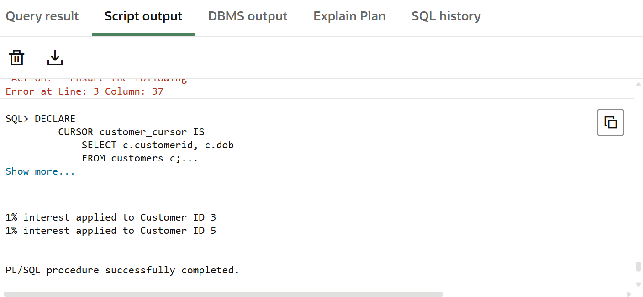

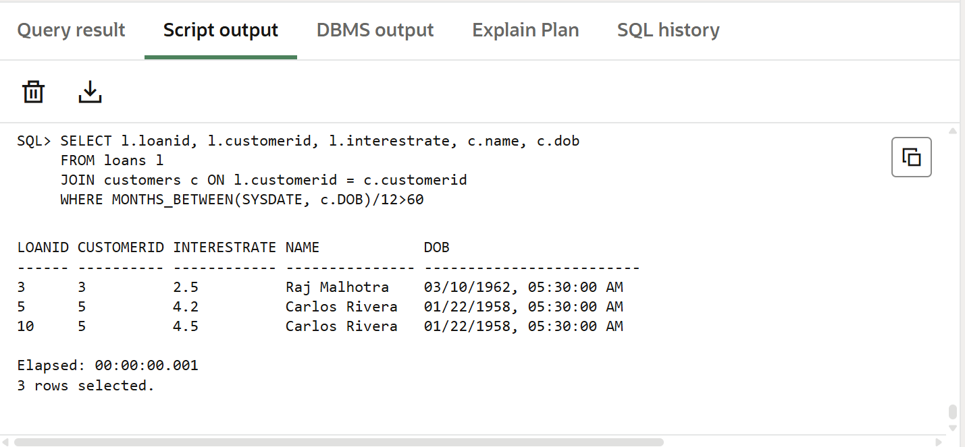

**Scenario 2:**

**Code:**

ALTER TABLE customers

ADD IsVIP CHAR(5) DEFAULT 'False';

DECLARE

    CURSOR customer_cursor IS

        SELECT customerid, balance

        FROM customers;

    v_customer_id   customers.customerid%TYPE;

    v_balance       customers.balance%TYPE;

BEGIN

    FOR customer_rec IN customer_cursor LOOP

        v_customer_id := customer_rec.customerid;

        v_balance := customer_rec.balance;

        IF v_balance > 10000 THEN

            UPDATE customers

            SET IsVIP = 'True'

            WHERE customerid = v_customer_id;

        END IF;

    END LOOP;

COMMIT;

END;

Select * From CUSTOMERS;

**Output:**

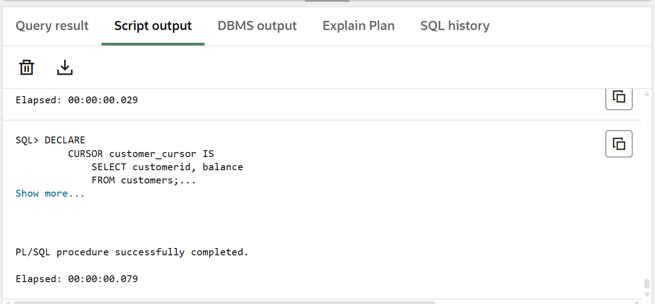

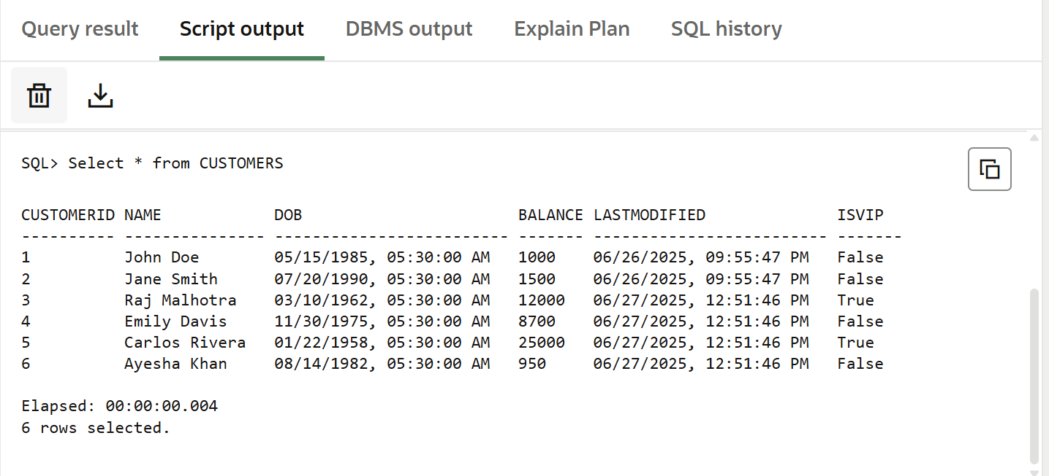

**Scenario 3:**

**Code:**

DECLARE

CURSOR loan_cursor IS

SELECT l.LoanID, l.CustomerID, l.EndDate, c.Name

FROM Loans l

JOIN Customers c ON l.CustomerID = c.CustomerID

WHERE l.EndDate BETWEEN SYSDATE AND SYSDATE + 30;

BEGIN

FOR loan_rec IN loan_cursor LOOP

DBMS_OUTPUT.PUT_LINE(

'Reminder: Loan ID ' || loan_rec.LoanID ||

' for customer ' || loan_rec.Name ||

' is due on ' || TO_CHAR(loan_rec.EndDate, 'DD-MON-YYYY')

);

END LOOP;

END;

/

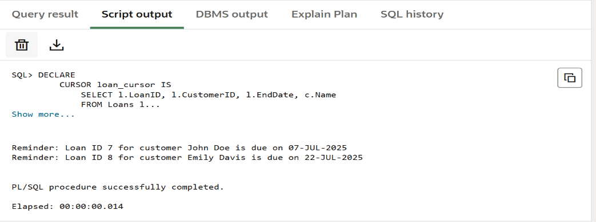

**EXERCISE 3: STORED PROCEDURES**

**Scenario 1:**

**Code:**

CREATE OR REPLACE PROCEDURE ProcessMonthlyInterest AS

BEGIN

    UPDATE Accounts

    SET

        Balance = Balance + (Balance * 0.01),

        LastModified = SYSDATE

    WHERE

        UPPER(AccountType) = 'SAVINGS';

    COMMIT;

END;

/

BEGIN

    ProcessMonthlyInterest;

END;

/

Select * from ACCOUNTS

Where UPPER(ACCOUNTTYPE)='SAVINGS';

**OUTPUT:**

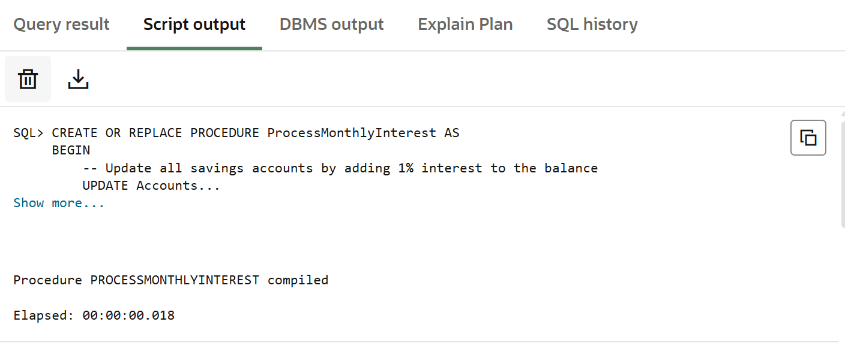

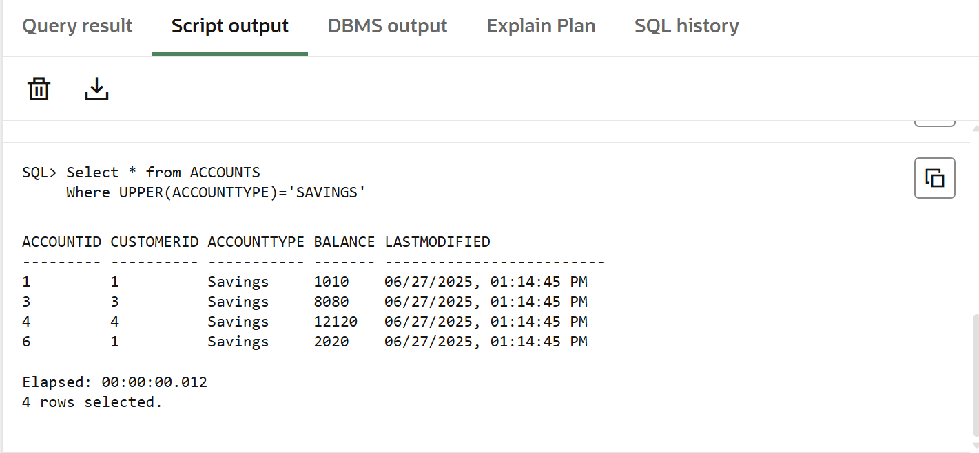

**Scenario 2:**

**Code:**

CREATE OR REPLACE PROCEDURE UpdateEmployeeBonus (

    p_DepartmentName IN VARCHAR2,

    p_BonusPercent IN NUMBER

)

AS

    CURSOR emp_cursor IS

        SELECT EmployeeID, Name, Position, Salary

        FROM Employees

        WHERE UPPER(Department) = UPPER(p_DepartmentName);

    v_NewSalary Employees.Salary%TYPE;

BEGIN

    FOR emp_rec IN emp_cursor LOOP

        -- Calculate new salary

        v_NewSalary := emp_rec.Salary + (emp_rec.Salary * (p_BonusPercent / 100));

        DBMS_OUTPUT.PUT_LINE('BEFORE -> ID: ' || emp_rec.EmployeeID ||

                             ', Name: ' || emp_rec.Name ||

                             ', Position: ' || emp_rec.Position ||

                             ', Salary: ' || emp_rec.Salary);

        UPDATE Employees

        SET Salary = v_NewSalary

        WHERE EmployeeID = emp_rec.EmployeeID;

        DBMS_OUTPUT.PUT_LINE('AFTER  -> ID: ' || emp_rec.EmployeeID ||

                             ', Name: ' || emp_rec.Name ||

                             ', Position: ' || emp_rec.Position ||

                             ', Salary: ' || v_NewSalary);

        DBMS_OUTPUT.PUT_LINE('-----------------------------------');

    END LOOP;

    COMMIT;

END;

/

BEGIN

    UpdateEmployeeBonus('HR', 10);

END;

/

**Output:**

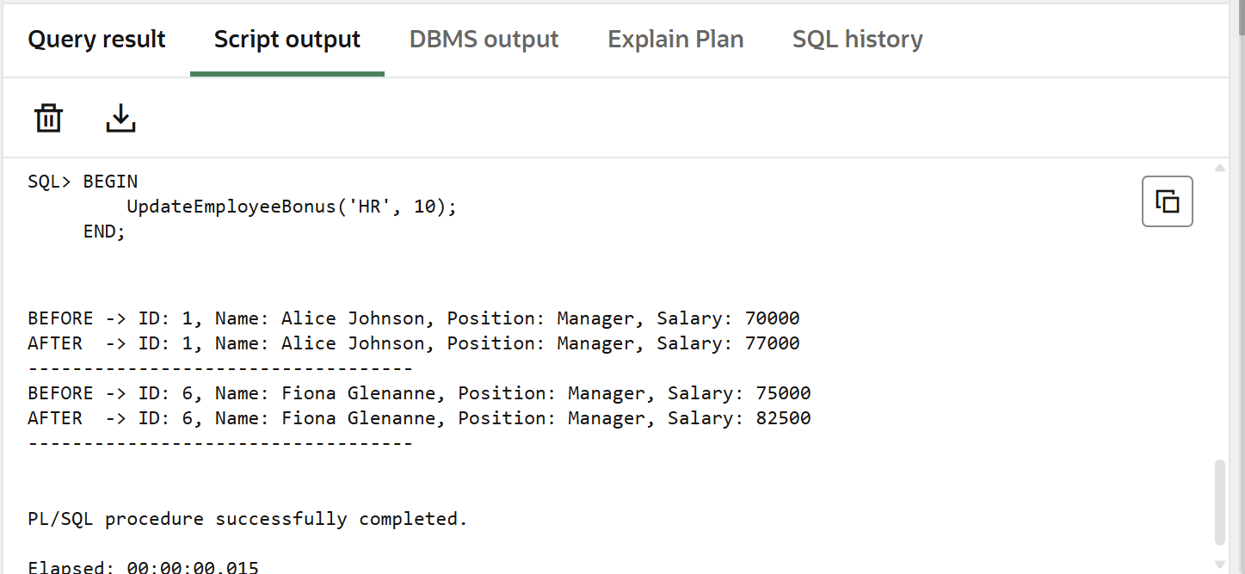

**Scenario 3:**

**Code:**

CREATE OR REPLACE PROCEDURE TransferFunds (

    p_FromAccountID IN NUMBER,

    p_ToAccountID IN NUMBER,

    p_Amount IN NUMBER

)

AS

    v_FromBalanceBefore Accounts.Balance%TYPE;

    v_ToBalanceBefore   Accounts.Balance%TYPE;

    v_FromBalanceAfter  Accounts.Balance%TYPE;

    v_ToBalanceAfter    Accounts.Balance%TYPE;

BEGIN

    SELECT Balance INTO v_FromBalanceBefore

    FROM Accounts

    WHERE AccountID = p_FromAccountID

    FOR UPDATE;

    SELECT Balance INTO v_ToBalanceBefore

    FROM Accounts

    WHERE AccountID = p_ToAccountID

    FOR UPDATE;

    IF v_FromBalanceBefore < p_Amount THEN

        RAISE_APPLICATION_ERROR(-20001, 'Insufficient balance in source account.');

    END IF;

    UPDATE Accounts

    SET Balance = Balance - p_Amount,

        LastModified = SYSDATE

    WHERE AccountID = p_FromAccountID;

    UPDATE Accounts

    SET Balance = Balance + p_Amount,

        LastModified = SYSDATE

    WHERE AccountID = p_ToAccountID;

    SELECT Balance INTO v_FromBalanceAfter

    FROM Accounts

    WHERE AccountID = p_FromAccountID;

    SELECT Balance INTO v_ToBalanceAfter

    FROM Accounts

    WHERE AccountID = p_ToAccountID;

    DBMS_OUTPUT.PUT_LINE('--- Transfer Summary ---');

    DBMS_OUTPUT.PUT_LINE('From Account ID: ' || p_FromAccountID);

    DBMS_OUTPUT.PUT_LINE('  Balance BEFORE: ' || v_FromBalanceBefore);

    DBMS_OUTPUT.PUT_LINE('  Balance AFTER : ' || v_FromBalanceAfter);

    DBMS_OUTPUT.PUT_LINE('To Account ID  : ' || p_ToAccountID);

    DBMS_OUTPUT.PUT_LINE('  Balance BEFORE: ' || v_ToBalanceBefore);

    DBMS_OUTPUT.PUT_LINE('  Balance AFTER : ' || v_ToBalanceAfter);

    COMMIT;

EXCEPTION

    WHEN NO_DATA_FOUND THEN

        RAISE_APPLICATION_ERROR(-20002, 'One or both account IDs are invalid.');

    WHEN OTHERS THEN

        ROLLBACK;

        RAISE;

END;

/

BEGIN

    TransferFunds(3, 6, 500);

END;

/

**OUTPUT:**

